PRACTICAL WORKSHEET – EXPERIMENT 1
Experiment Title
Design and Implementation of a Library Management System Database Using SQL

1. Aim of the Session
The aim of this practical session is to design and implement a Library Management System database using SQL by creating tables with appropriate constraints and demonstrating Data Definition Language (DDL), Data Manipulation Language (DML), and Data Control Language (DCL) operations.

2. Objective of the Session
After completing this practical, the learner will be able to:
- Design a relational database using primary and foreign keys
- Apply constraints to ensure data integrity
- Perform DDL and DML operations
- Understand role-based access control using DCL commands
- Gain exposure to database security concepts

3. Practical / Experiment Steps
- Design tables for books, library visitors, and book issue records.
- Apply primary key, foreign key, NOT NULL, UNIQUE, and CHECK constraints.
- Insert sample records into all tables.
- Create a database role named Librarian.
- Grant required privileges to the role.
- Revoke privileges to demonstrate access control.

4. Procedure of the Practical
(i) Start the system and log in to the computer.
(ii) Open Oracle Live SQL / SQL*Plus.
(iii) Drop existing tables and roles if present.
(iv) Create tables using CREATE TABLE commands with constraints.
(v) Insert data into tables using INSERT statements.
(vi) Create a role and assign privileges using GRANT commands.
(vii) Revoke privileges using REVOKE commands.
(viii) Verify execution results and capture screenshots.

5. I/O Analysis (Input / Output Analysis)
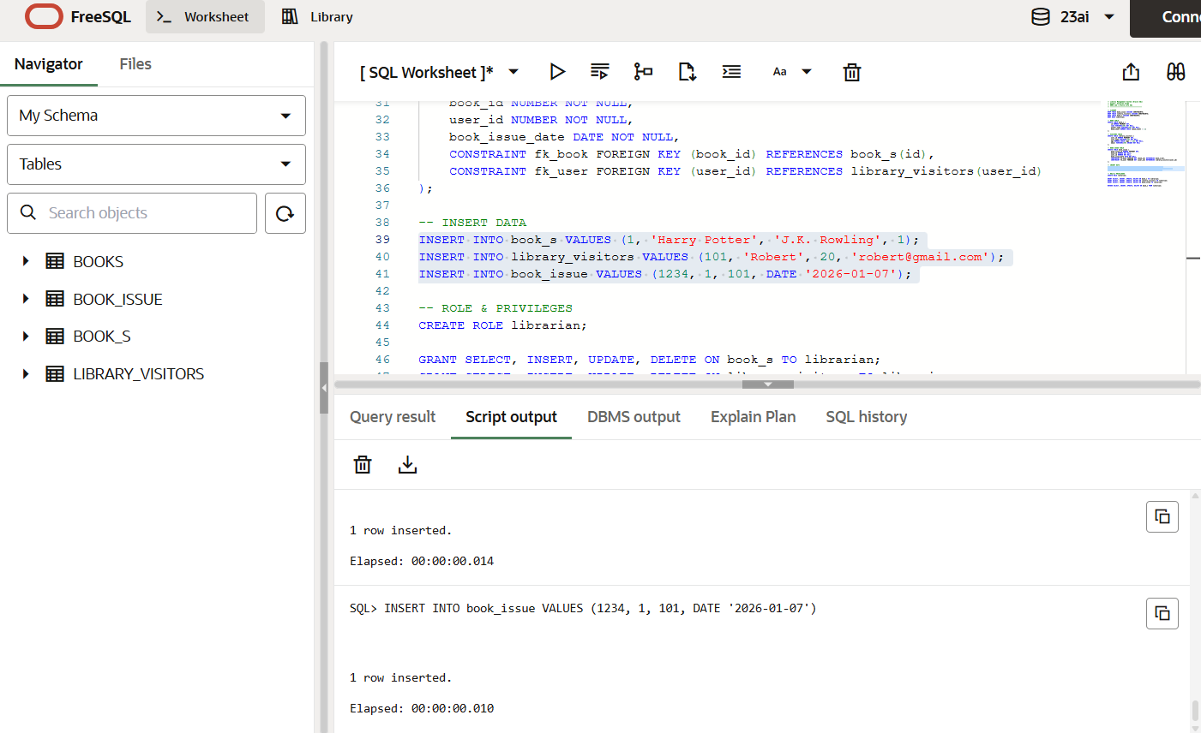
I

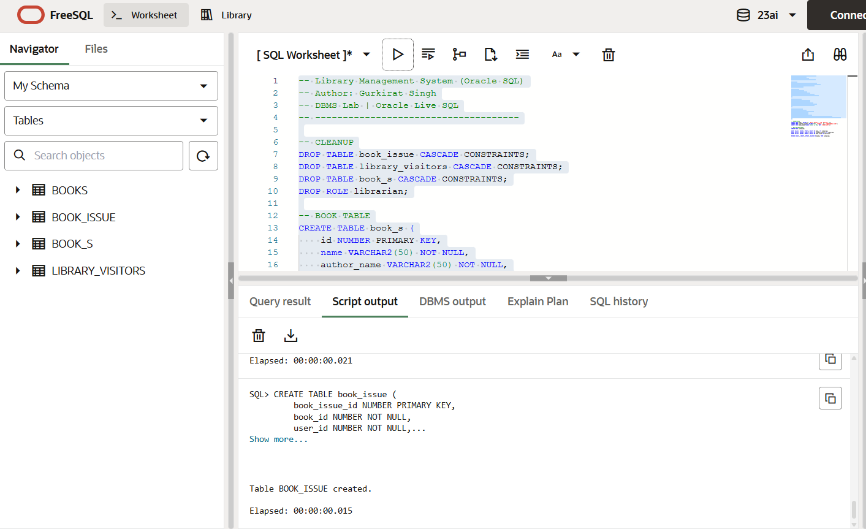

Input
- SQL commands for table creation
- INSERT statements for sample data
- DCL commands for role creation and privilege management
Output
- Tables created successfully
- Data inserted without constraint violations
- Referential integrity maintained
- Role and privilege commands demonstrated
(Screenshots attached showing execution and outputs)

6. Learning Outcome
From this practical, the student learned:
- Database schema design for real-world applications
- Implementation of constraints for data integrity
- Usage of DDL, DML, and DCL commands
- Role-based database security concepts
- Practical exposure to Oracle SQL environment

